# Exercises: WordPress Themes

Problems for exercises and homework for the [“WordPress Basics for Teachers” course @ SoftUni](https://softuni.bg/trainings/2157/wordpress-basics-for-teachers-september-2018).

In this homework, you are supposed to install and configure a **WP theme** in your WordPress site and to setup a **visual editor** for your WP site. You will build a **simple web site** based on popular WP theme and using a visual editor:

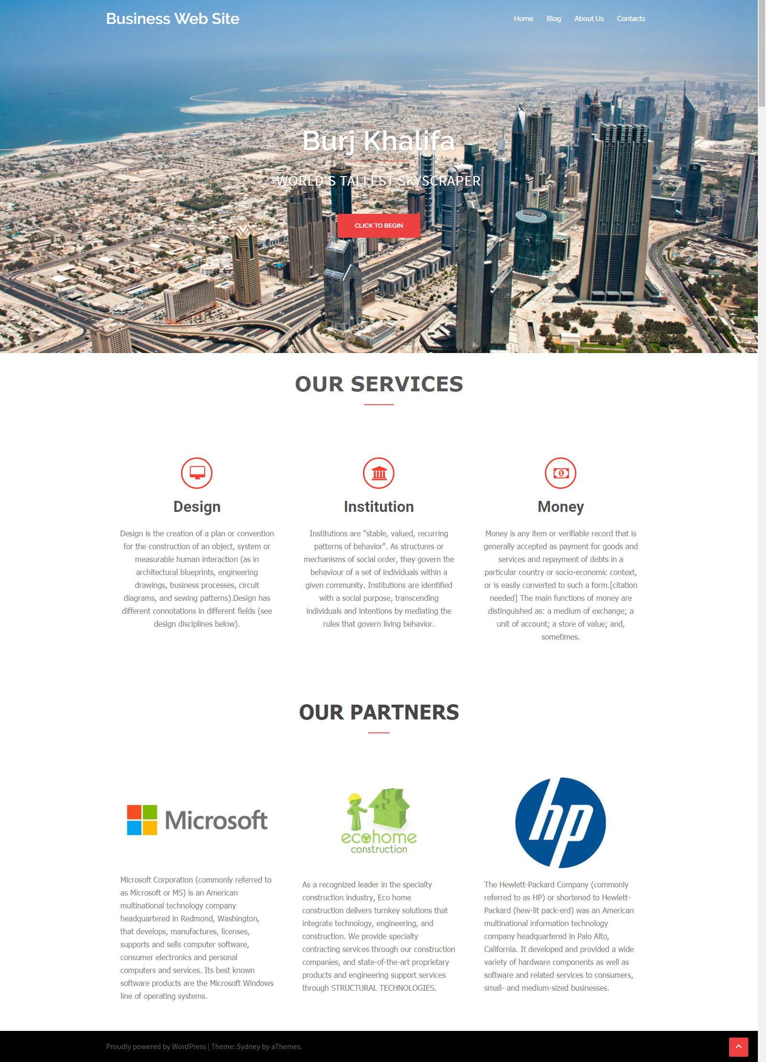

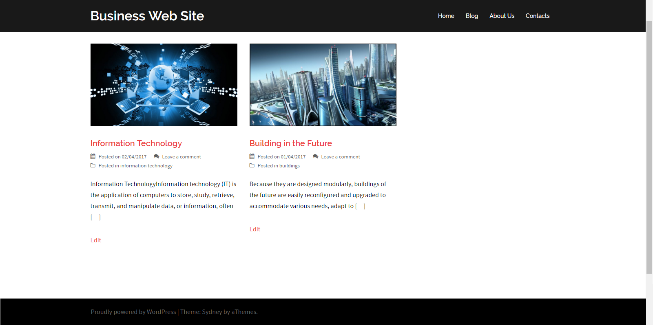

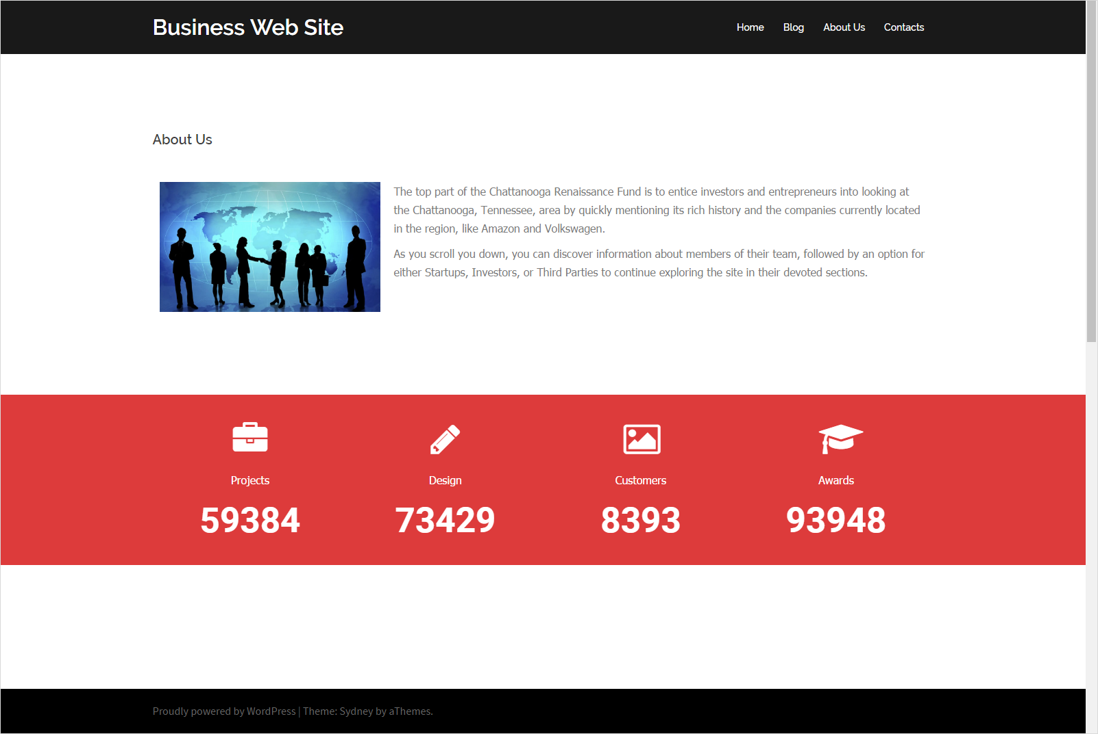

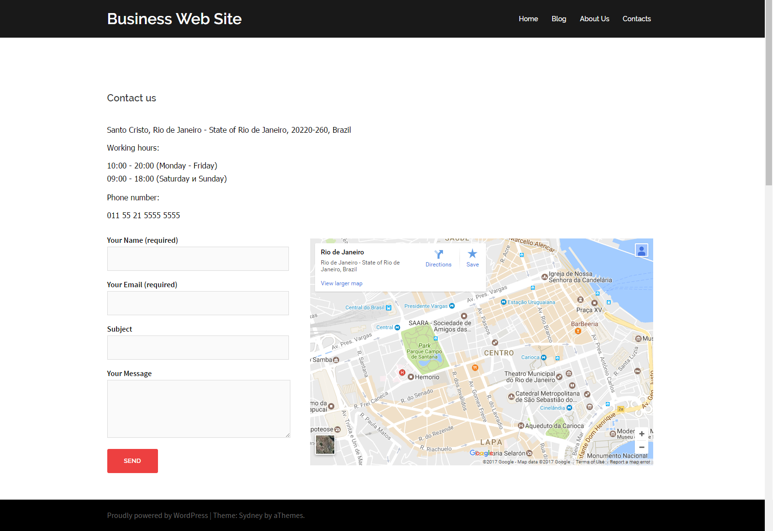

Did you like this web site? What about creating it from scratch?

## Install the “Sydney” WordPress Theme

Open your WordPress on your **site** e. g, <http://www.yourdomain.website.tk/wp-admin/> go to **Appearance** -> **Themes** -> type in search box “**Sydney**”, **install** it and them **activate** it.

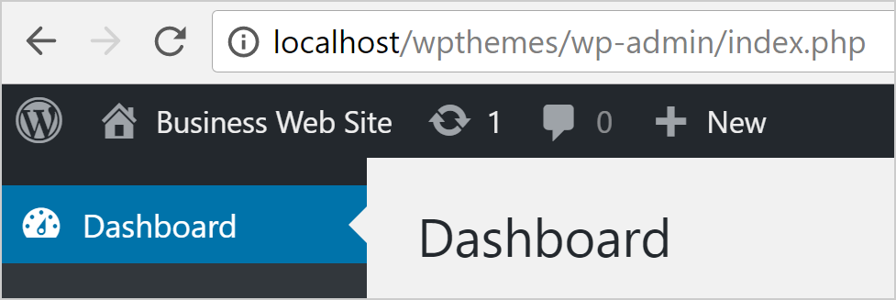

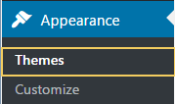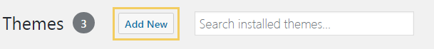



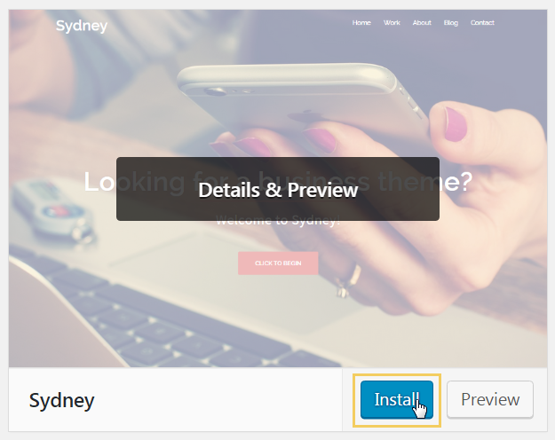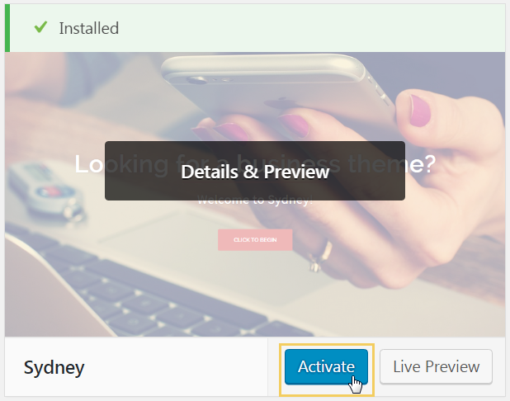

The theme should display the **home page** of your WordPress site like at the screenshot below:



Now it is time to **customize your theme** and Web site and **build a few pages**.

## Install the “Elementor” Plugin

The easiest way to build site pages is to install and use a **visual page builder**. We shall use a powerful, free, visual page builder (page editor) for WordPress, called “**Elementor**” (learn more at [https://elementor.com](https://elementor.com/)).

Let’s **install** and **activate** the “**Elementor**” WP plugin:

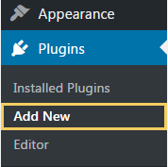 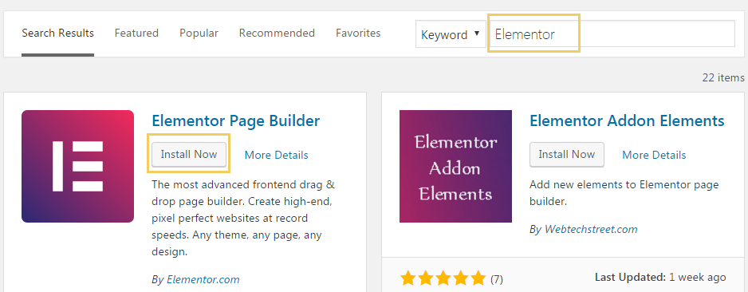

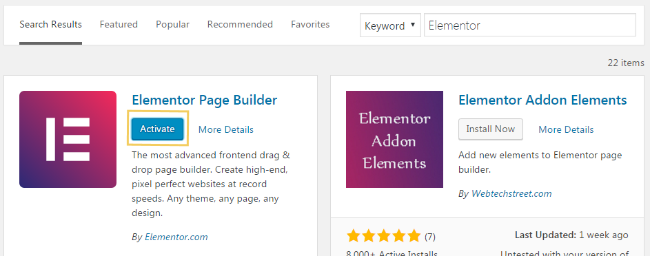

## Configure the Site Settings

Follow the screenshots to setup your **site configuration settings**. First enable SEO-friendly URLs for your posts:

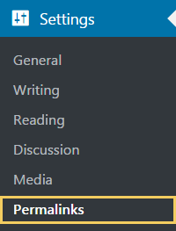 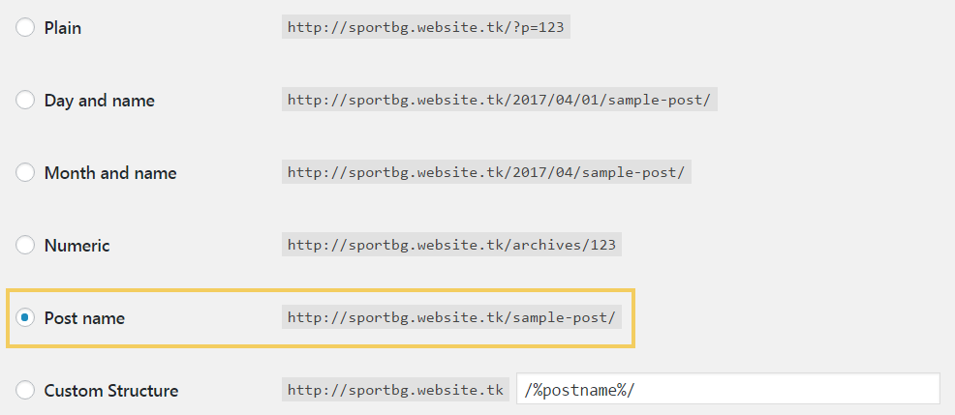

Modify some other site settings:

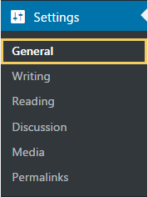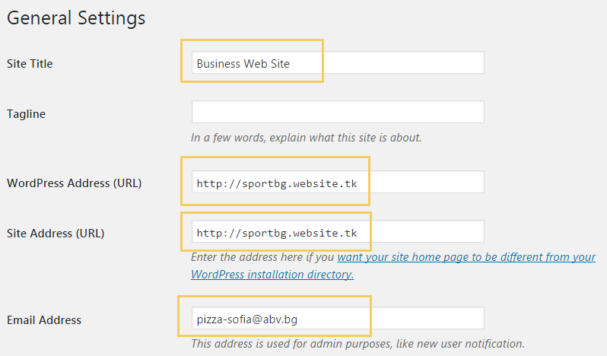

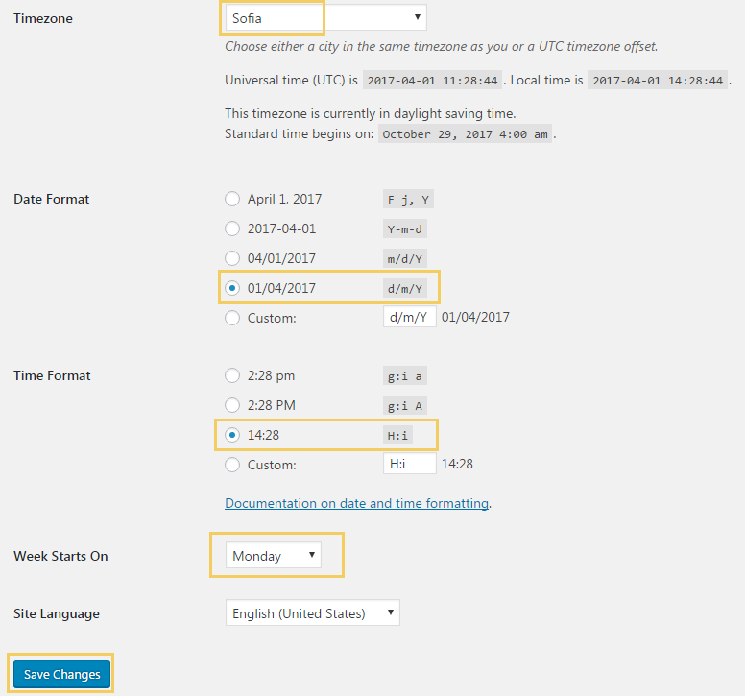

## Upload the Media Files

You are provided with a few **images** for your Web site. **Upload them** in your media library:

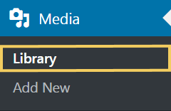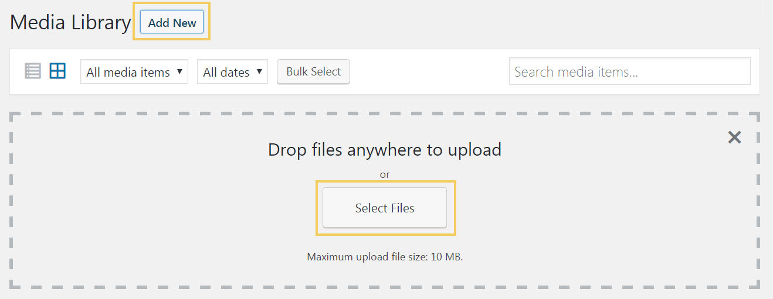

## Create “Home” and “Blog” Pages

The term “**home**” or “**home page**” or “**front page**” is used in Web development to refer to the main page of a Web site. It is often used in the navigation menus and other user interface elements of the website to direct users to the main page. By **default**, a WordPress website shows a home page listing your latest posts in reverse order by date.

* Go to your WordPress **Dashboard** 🡪 [**Pages**] 🡪 [**Add New**].
* Title your first page “**Home**”.
* Go to the Page attributes on the right side and select “**Front Page**” in the **Template** drop down. This will display this page using the home page template (as front page).
* Click the **[Publish]** button.

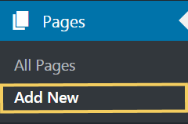 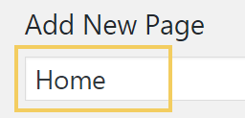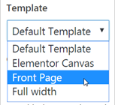

Create a “**Blog**” page:

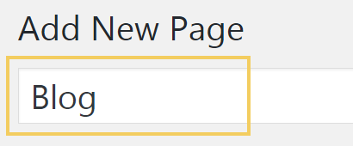

Now you need to assign the “**Home**” page as your site front page and the “**Blog**” page as your site blog posts page:

* Go to your **Dashboard** 🡪 [**Appearance**] 🡪 [**Customize**].
* Click on the tab that says “**Static Front Page**”.
* Choose “**[A static page]**” button.
* For the front page, go to the drop down and select the **Home** page you just created.
* For the blog page, go to the drop down and select the **Blog** page you just created.
* Click the blue **[Save and Publish]** button.

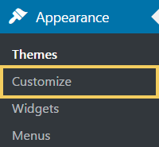 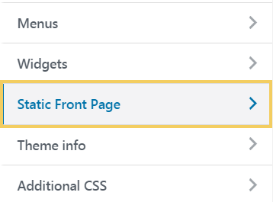 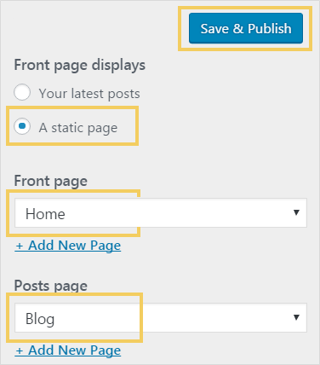

Check what you have configures so far. **Open your Web site** in your Web browser:

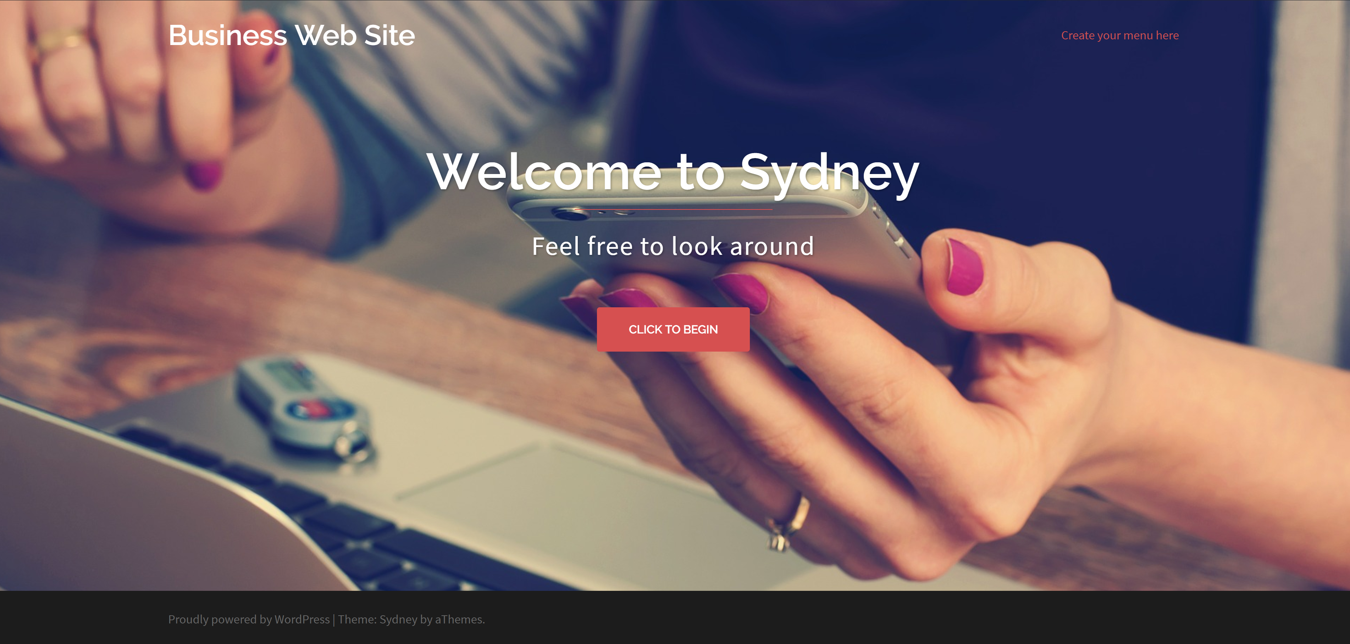

## Customize the Site Menus

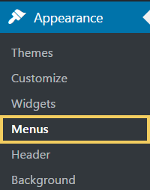 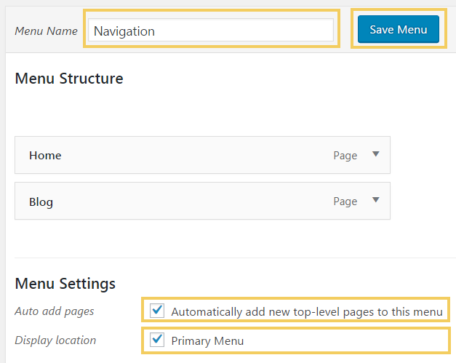

Now your web site has **menus**. You can open it to see the menus.

## Edit Header Type and Slider

Customize the **slider at the front page**:

* Go to your **Dashboard** 🡪 Hover over [**Appearance**] 🡪 Click on[**Customize**].
* Click on the **[Header Area]** tab.
* Click on **[Header Slider]**.
* Change your **slider images** and **text** to whatever you want.

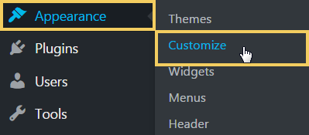 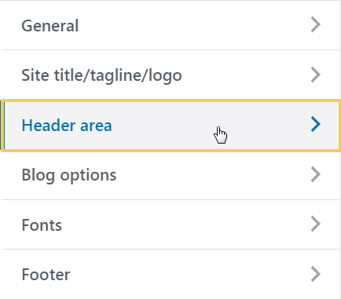 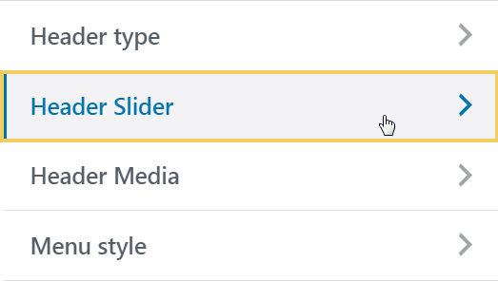

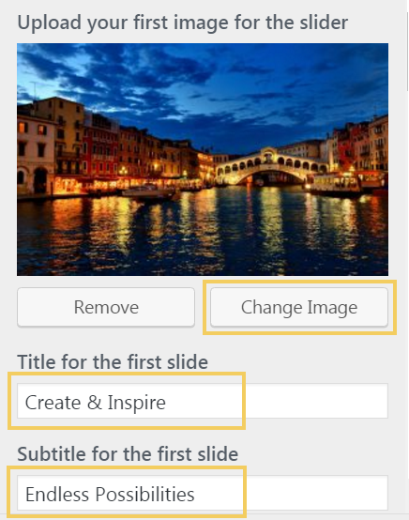

Customize the site **header area**:

* Click the **[Header type]** area.
* For **front page header** type – make sure “**Full screen slider**” is selected.
* **Site header** type – select “**No Header (menu only)**” to disable the image /slider header for the pages.

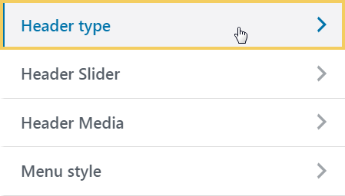

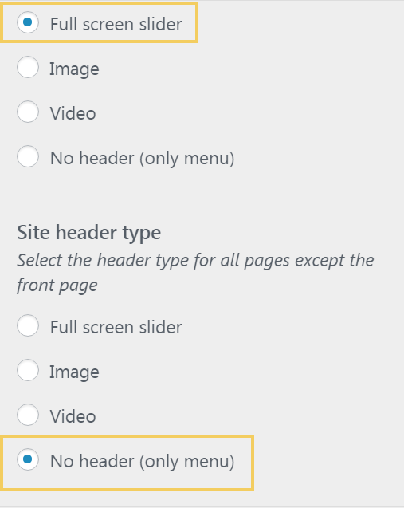

Now customize the **Blog Options**:

* Change the blog layout to **Masonry Grid**

**Masonry** is a grid layout based on **columns**. Unlike other grid layouts, it doesn’t have fixed height rows. Basically, Masonry layout optimizes the use of space inside the web page by reducing any unnecessary gaps. Without this type of layout, certain restrictions are required to maintain the structure of layout.

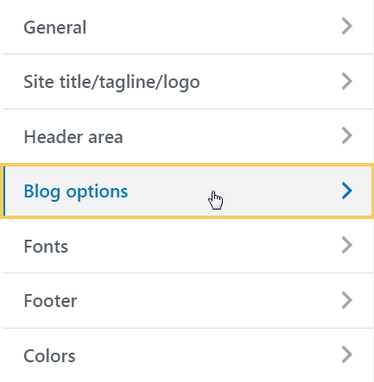 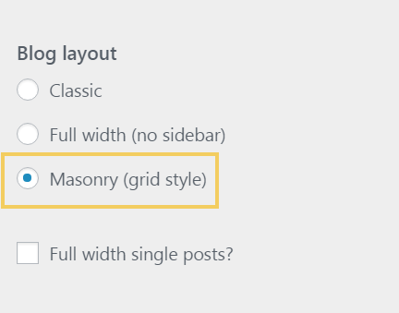

Now change the site **Colors**:

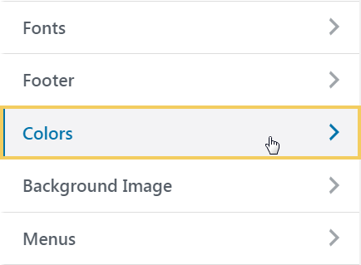 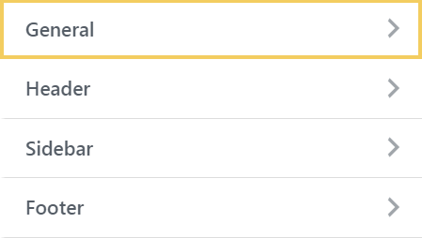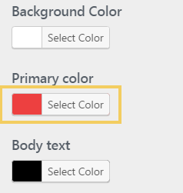

Assign a primary color: #ed4040.

## Create the “Home” Page

Now create the site **home page** using the **Elementor** page builder.

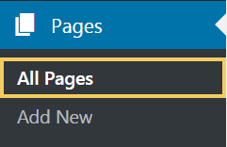 

### Create “Our Services” Section Header

First add “**Our Services**” section heading:



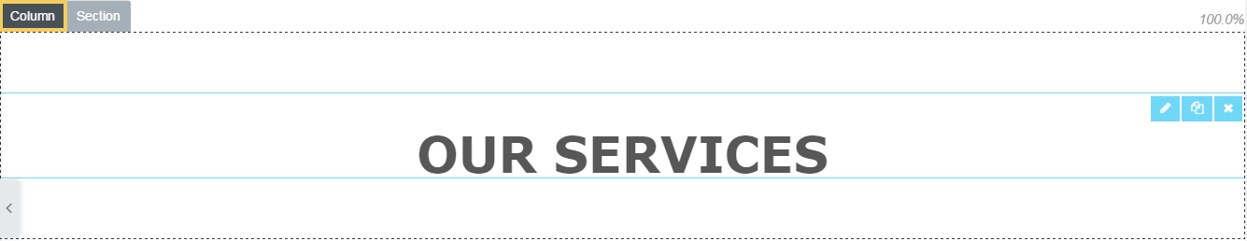 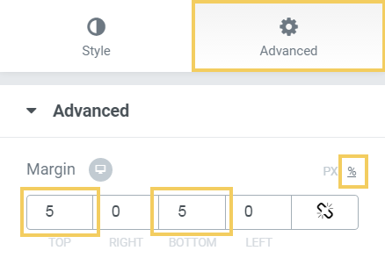

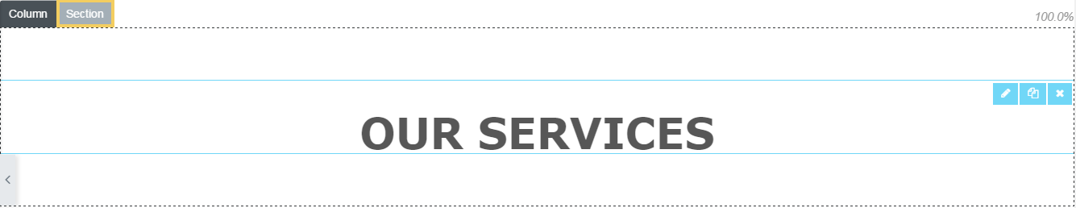

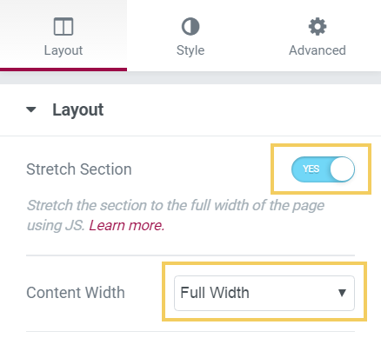

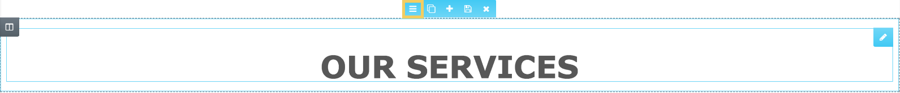

Text color: **#575757**

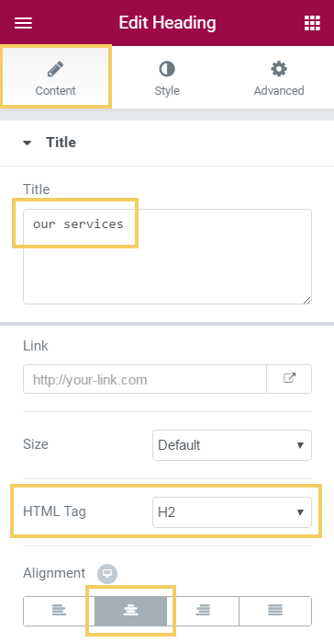 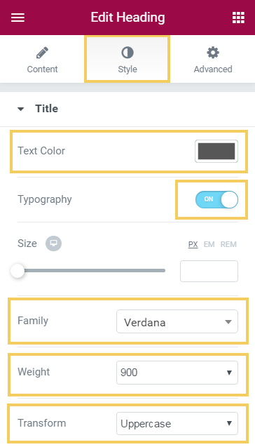 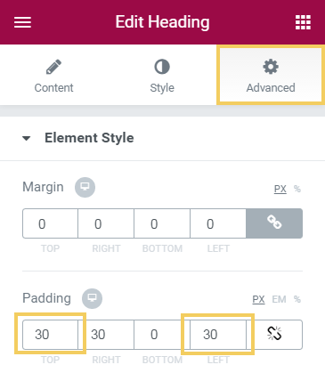

Now add **Divider** widget in the section header:

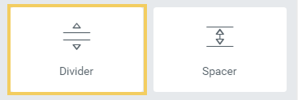

Color: #FC5050

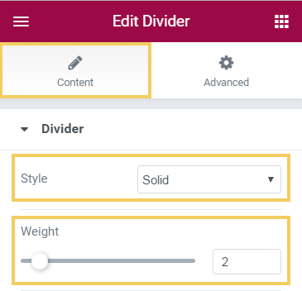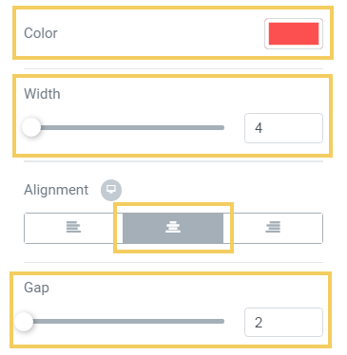

Now the “**Our Services**” section heading should look as follows:



### Create “Our Services” Section Icons

Now you shall build a **section with 3 columns** to hold the company services (icon + title + service description):

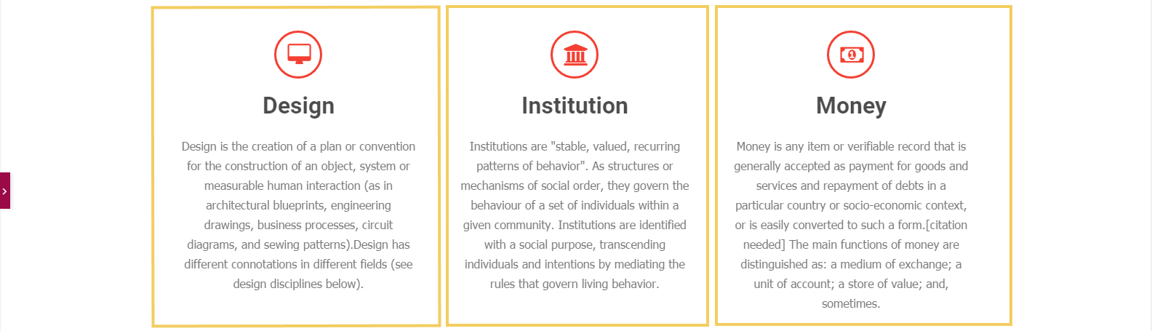

First add a **new section**:



Use **3-equal-columns** layout:

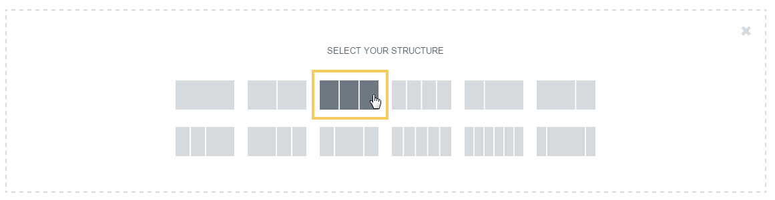

Put **“Icon Box” widgets** in the 3 columns you just created:

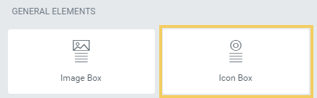

The page editor should look like shown below:

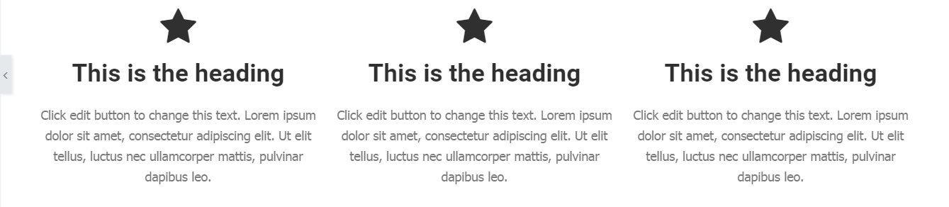

Now **customize the icon boxes**:

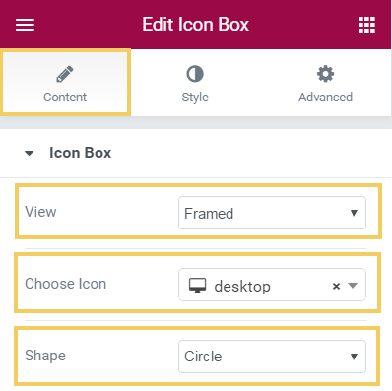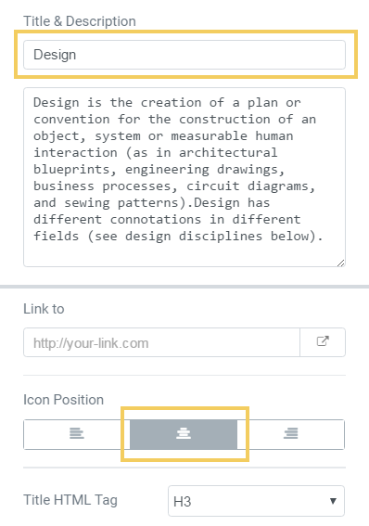

Use these icons: "**desktop**", "**institution**", "**money**". Change the colors, spacing, size and paddings:

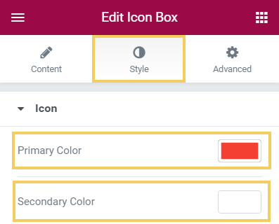 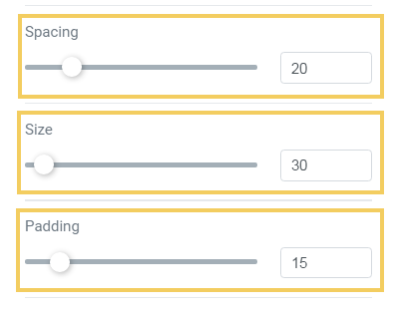 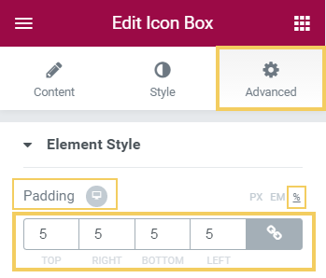

Use the following color: **#f44033**.

### Create “Our Partners” Section

Now you shall **create the section “Our Partners”**, shown below:



First **drag a “Heading” widget** over the “**Add New Section**” button.



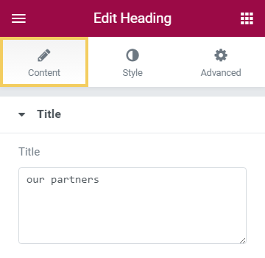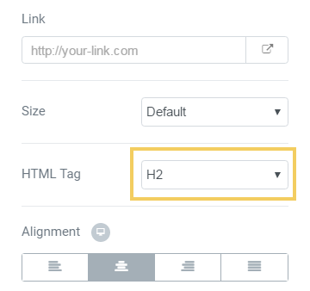

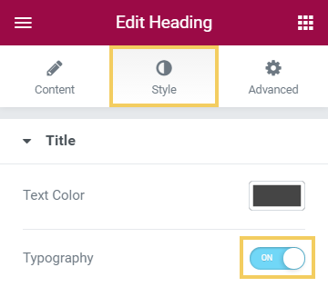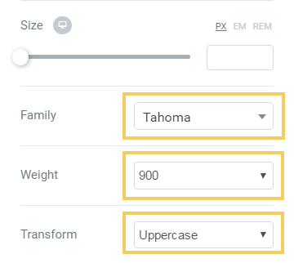

Add a new section, holding **3 equally-sized columns**:



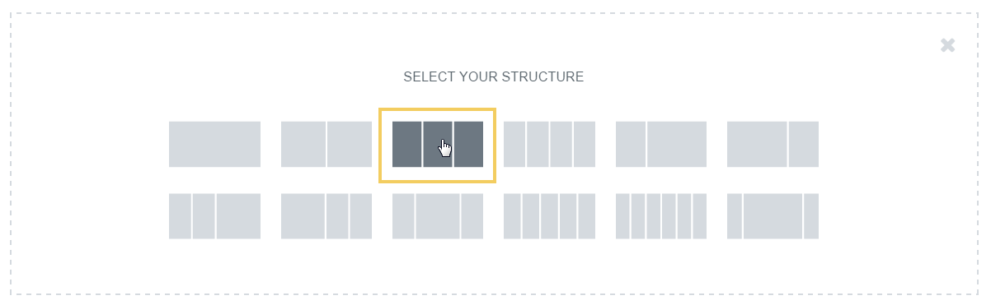

In each column drag an **“Image” + “Text Editor” widgets**:



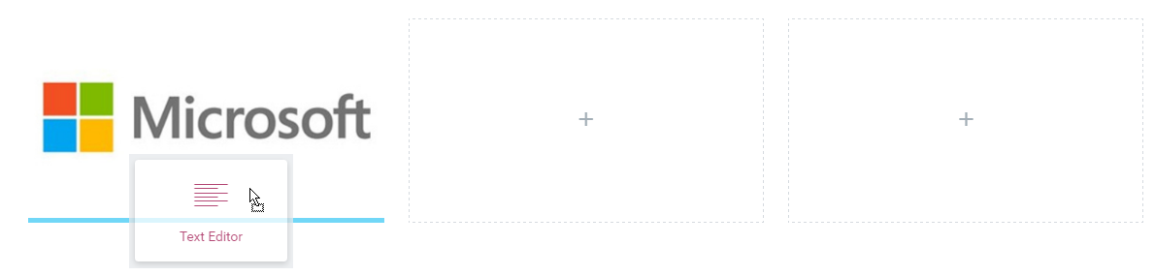

Put the company **logos** and the company **description texts**:

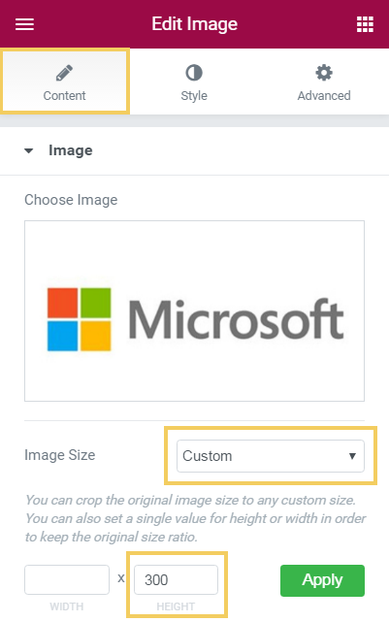 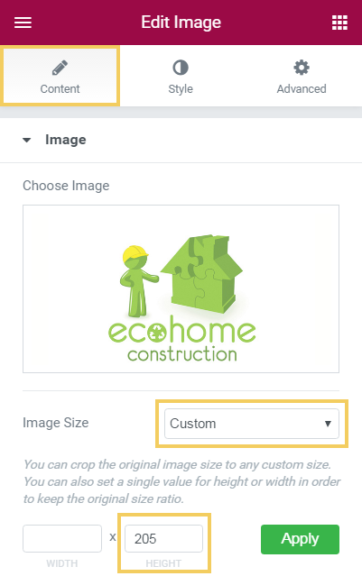 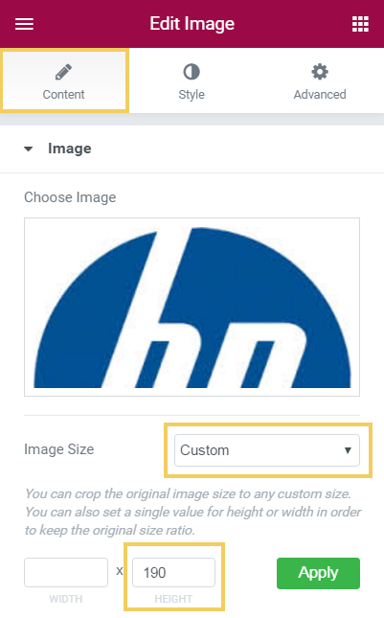

And you are ready with the site **“Home” page**. Open your web site and look at its front page. It should look like this:

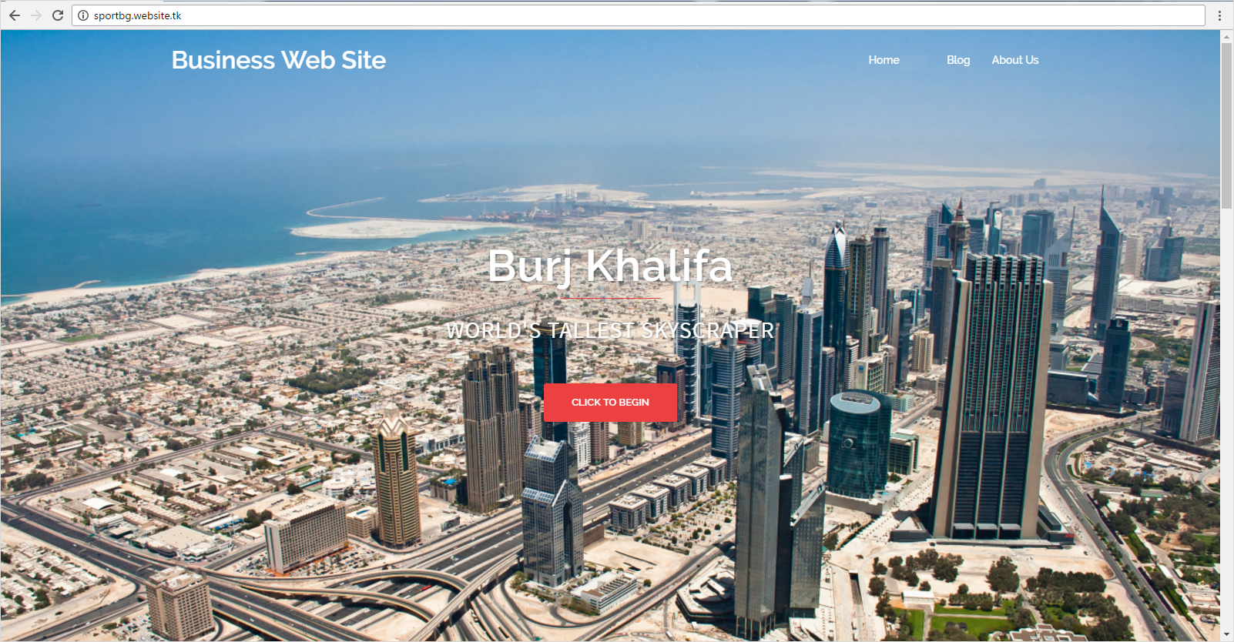

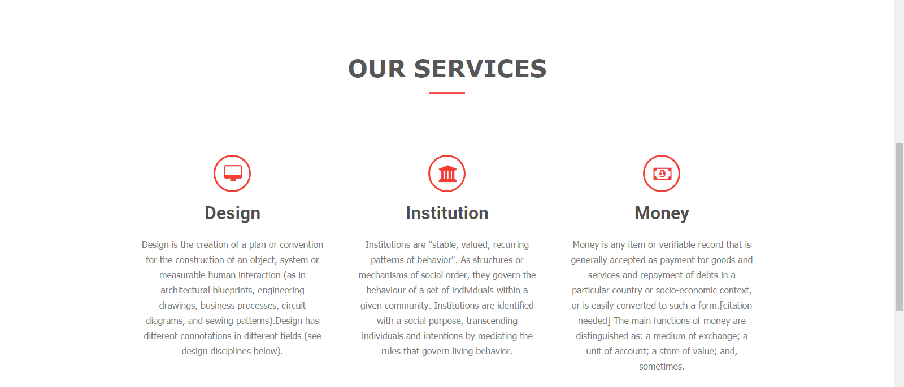



## Create “Blog” Page and Add Posts

First you should **create a few posts**. Use the texts provided as resources to this exercise.

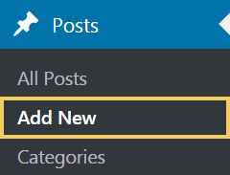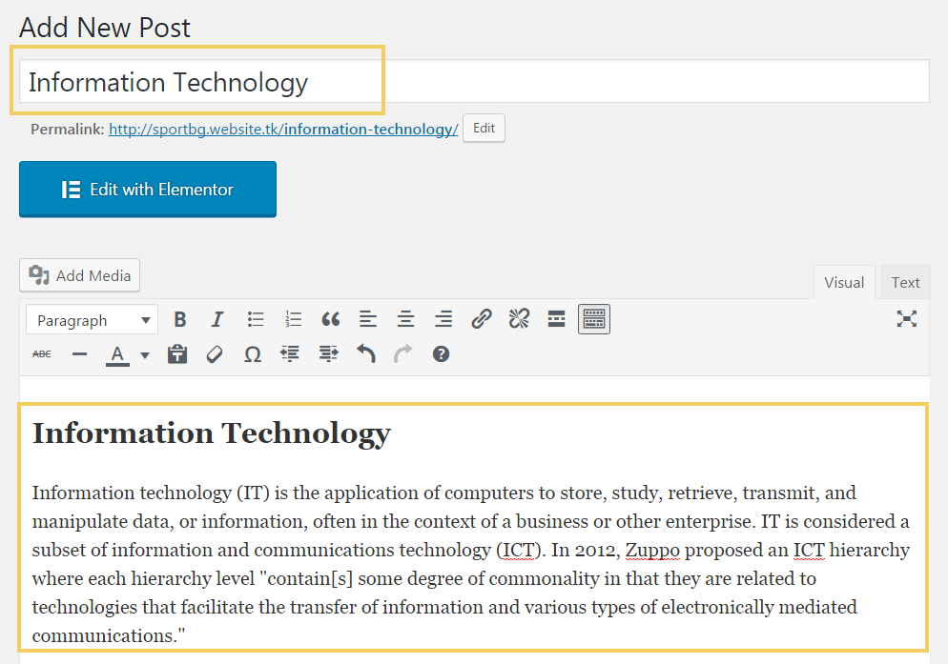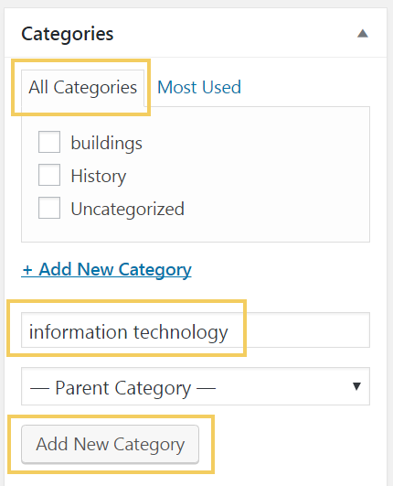

Assign **tags** and a **featured image**:

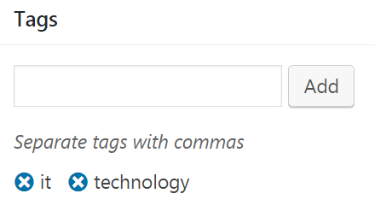

Now browse your **[Blog]** page and you should see your **recently added two posts** “Information Technology” and “Building the Future”:

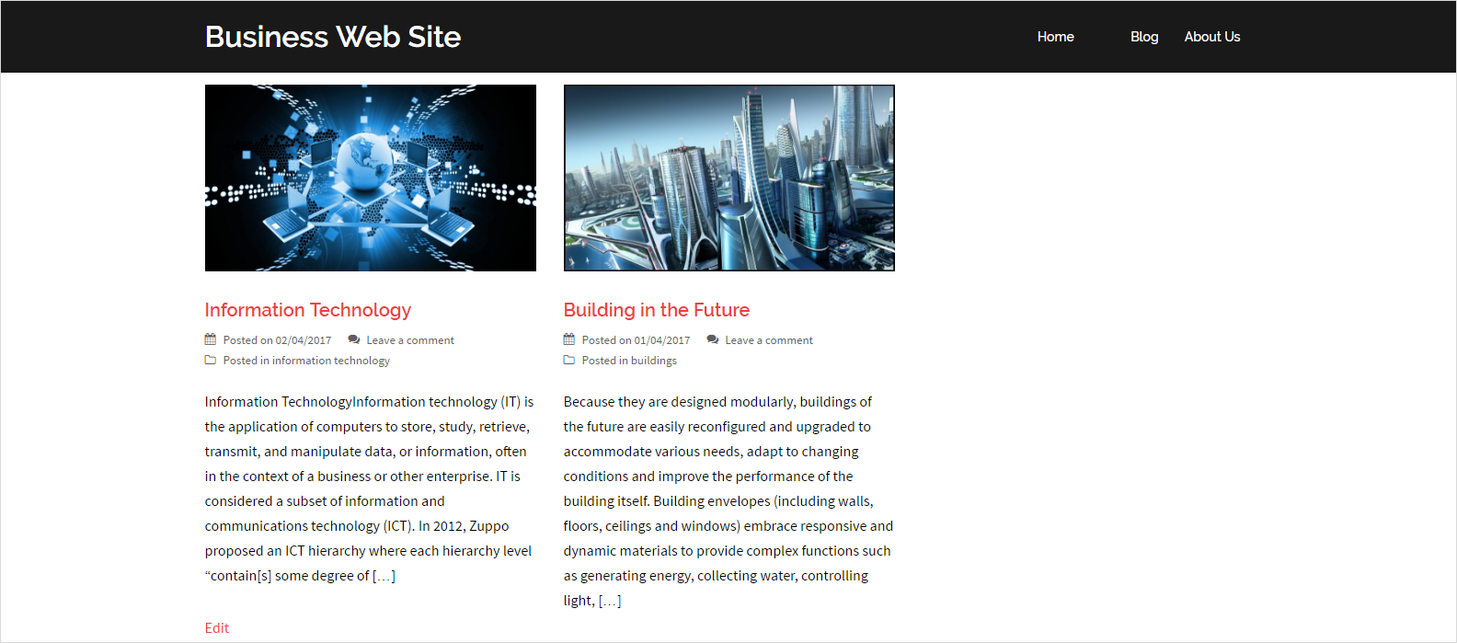

Click on the image inside some of the posts and you should see the full post in separate page like this:



## Social Media and Share Icons

Install a social **plugin** widget, e.g. "**Social Media and Share Icons (Ultimate Social Media)**" and add categories to your sidebar, like it is shown on the screenshots:

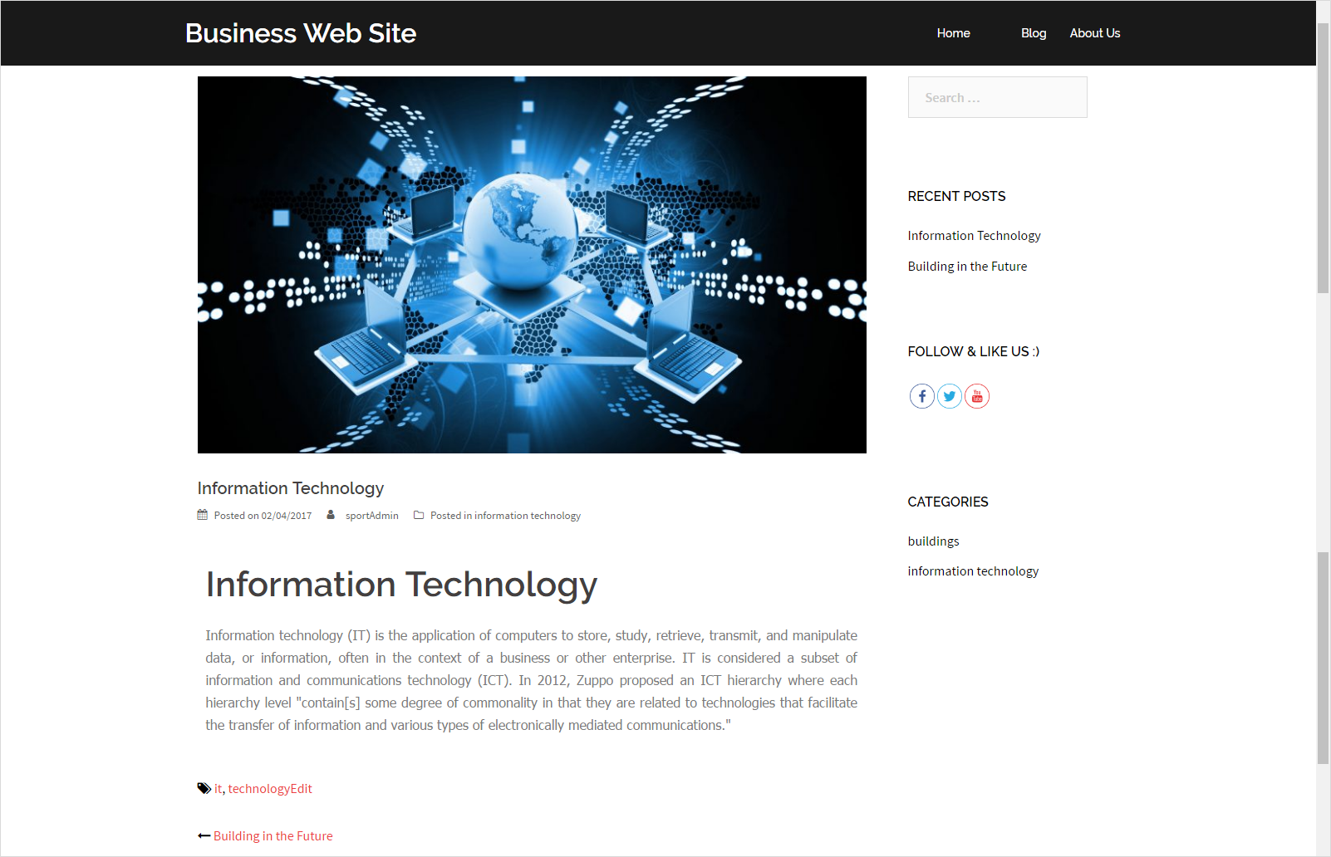

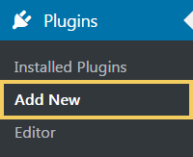

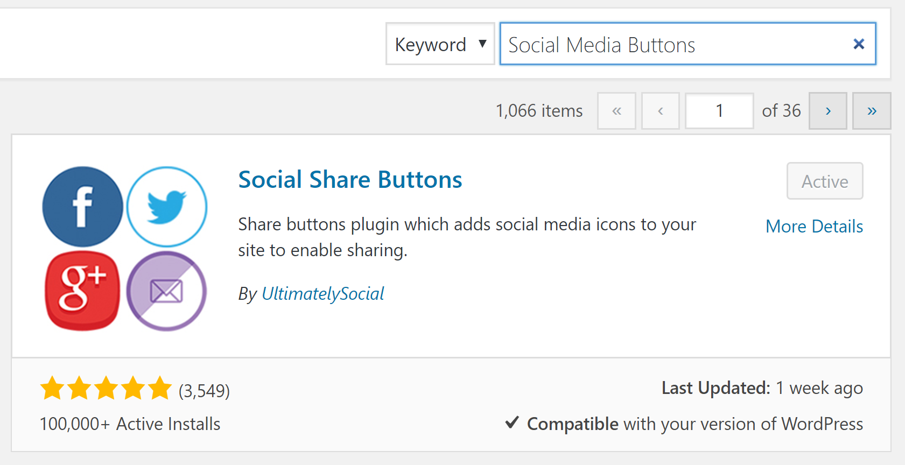

**Active** the plugin that you have just installed.

Add a **new widget** to your **sidebar**:

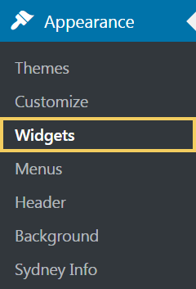 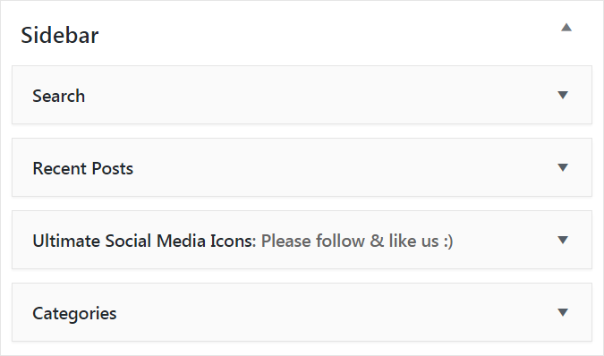

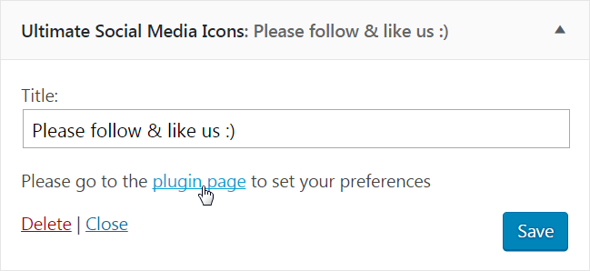

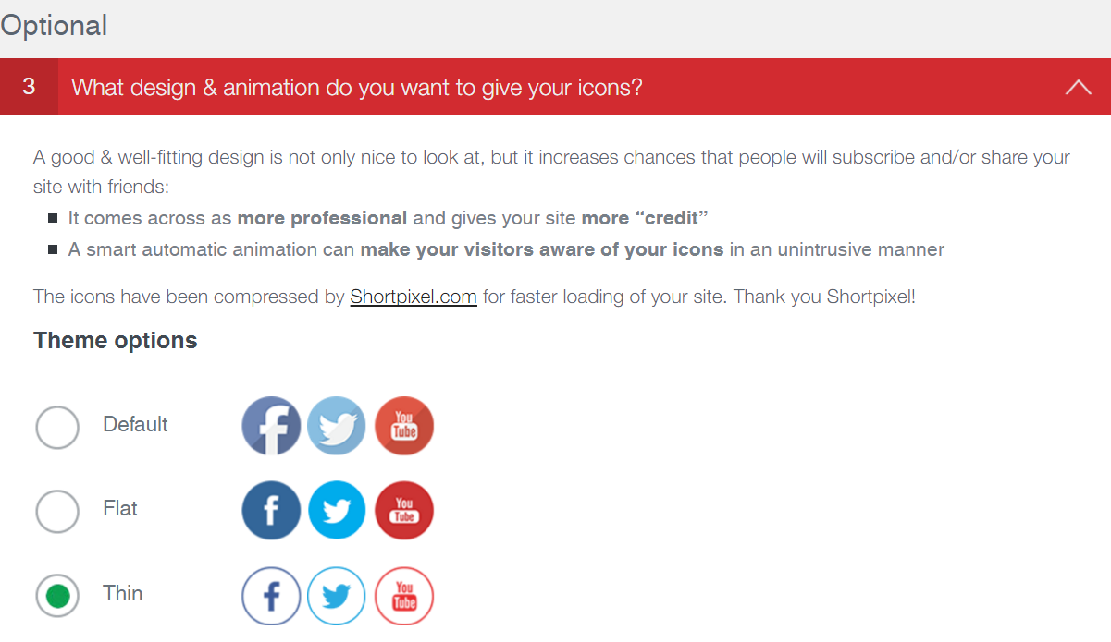

Test your site. The social share icons shoul appear in the sidebar for your blog posts:



## Create the “About” Page

New you shall create the site **“About” page**. It should look like this (with beautiful **animated counters**):

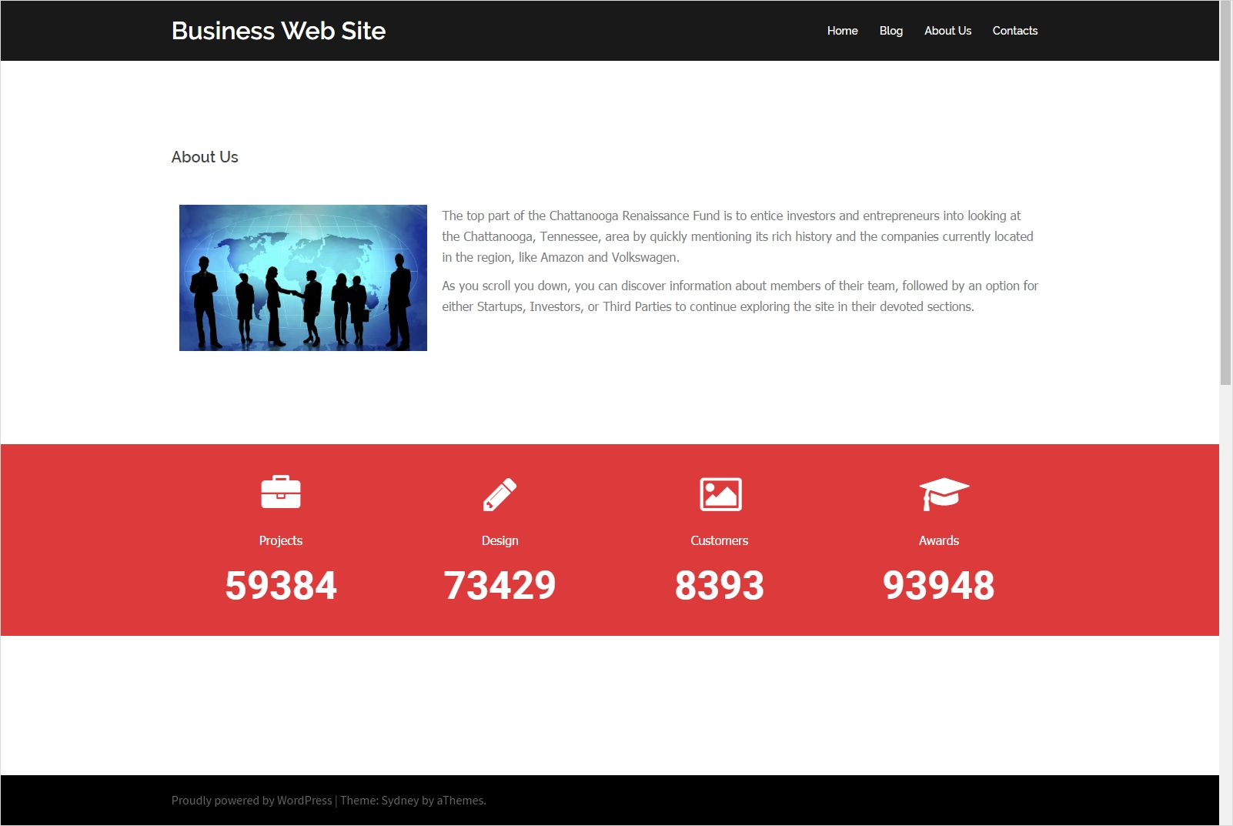

Create a **new page “About Us”** and edit it with the “**Elementor**” page builder.

### Create the “Image + Text” Section

To create the first section in the about page (**image** + **text**) just follow the screenshots:

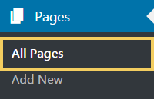

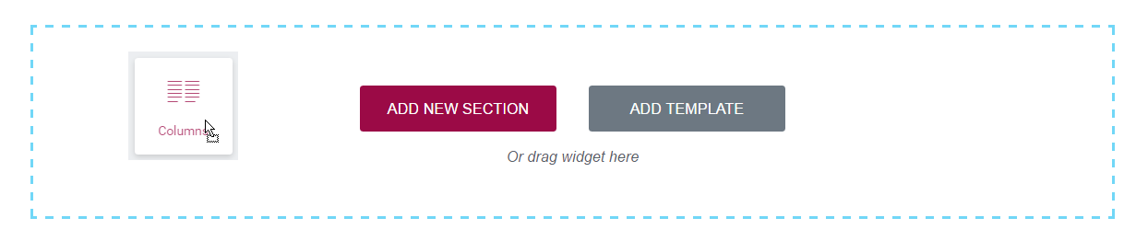

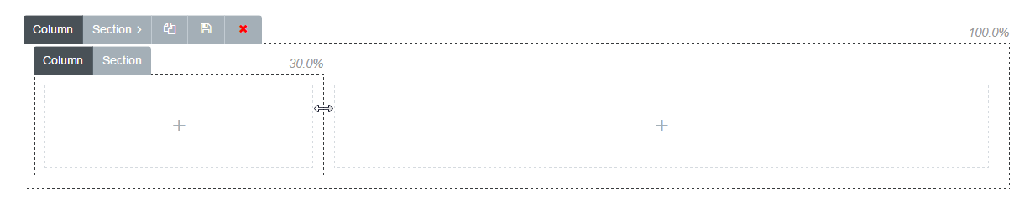





### Create the “Icons + Numbers” Section

To create the second section in the about page (**icons** + **numbers**) follow the screenshots.

Add a **4-column section** and put **“Icon” + “Text” + “Counter” widgets** in each column:

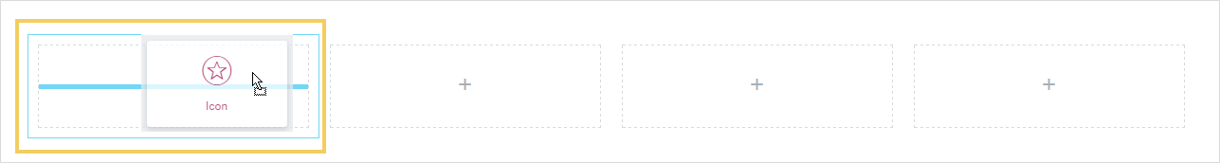

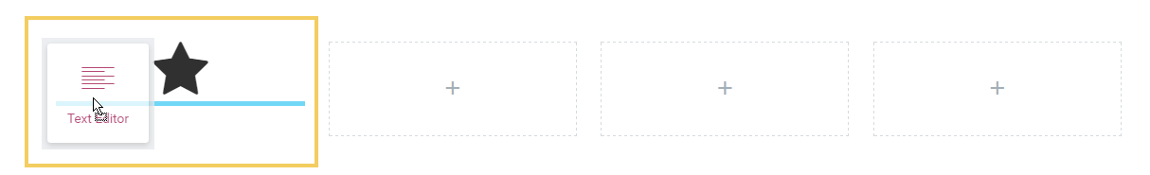

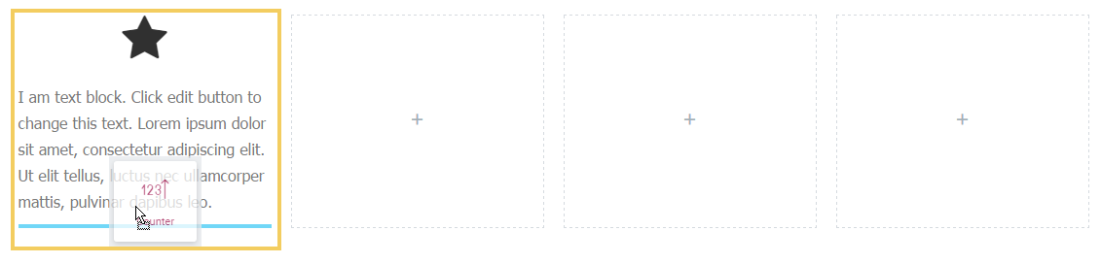

**Configure** the **icons**, **texts** and **counters** using the editor.

* Color: **#dd3b3b**.
* Icons: **briefcase**, **pencil**, **image**, **graduation-cap**.

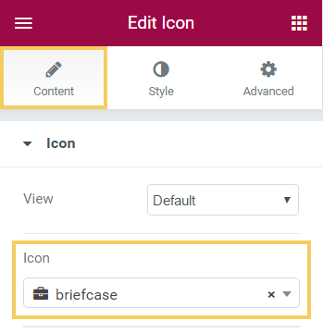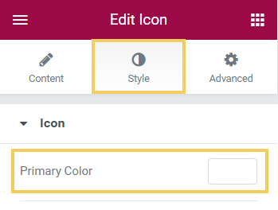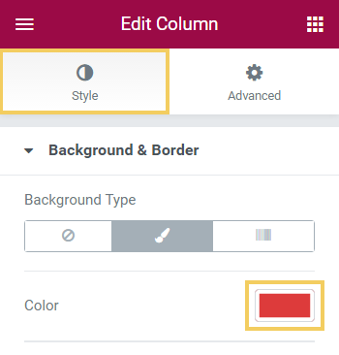

## Create the “Contacts” Page

Your **“Contacts” page** should look as follows (**text block** + **contact form** + **map**):



### Install the “Contact Form 7” Plugin

Install the plugin “**Contact Form 7**”. It will be used for your contact form.

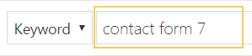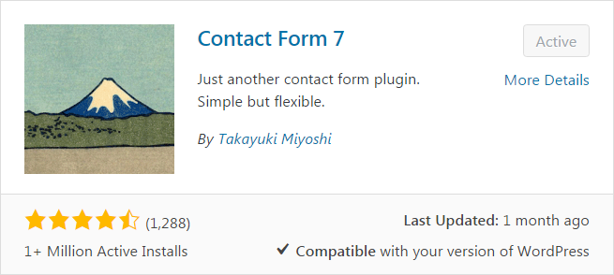

The plugin allows you to create forms and provides short codes to insert them in your web site. Form data is sent through email (so you need to configure your WordPress email settings). Form data is not stored in the database.

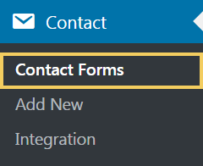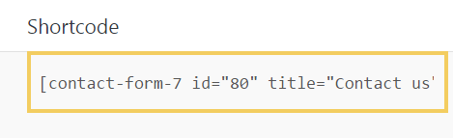

### Build the “Contact Us” Page Content

Now you need to **create new page “Contact Us”** and add it to the site top menu:

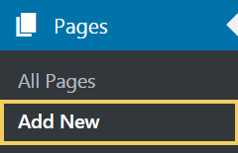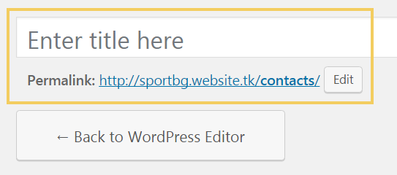

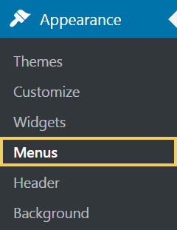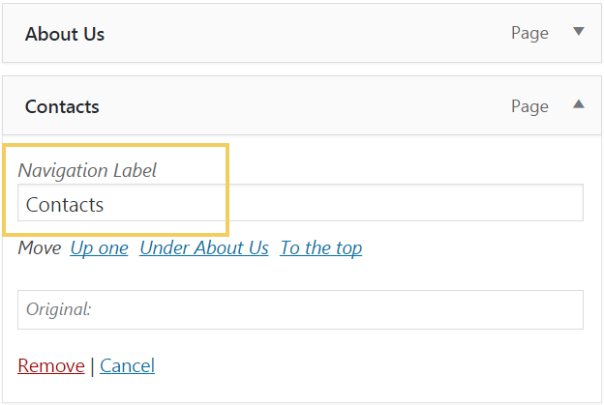

Now edit the **“Contacts” page** with **Elementor**.

### Create the “Contact Info” Section

First create a single column section and put a text block in it. Insert your text inside (**address**, **working hours** and **phone number**):



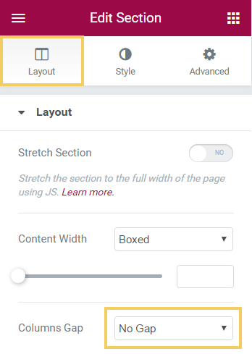

### Create the “Contact Form + Map” Section

Next, create a **two-column section** and put the **contact form** + the **map** inside:



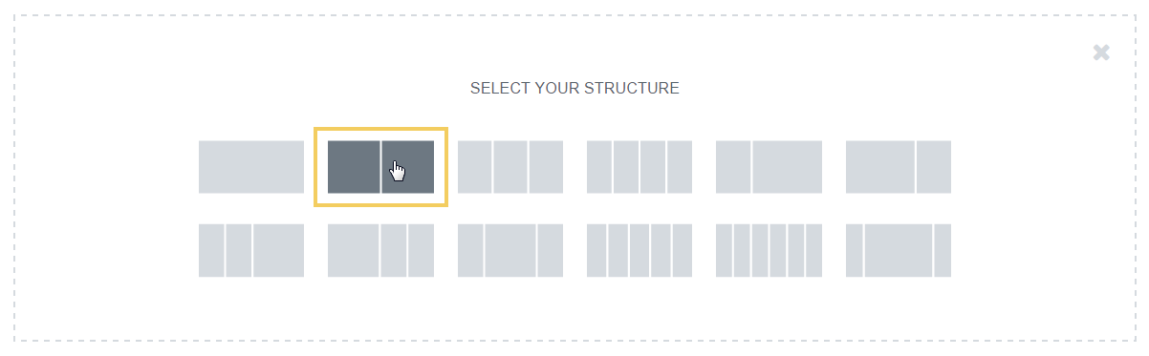

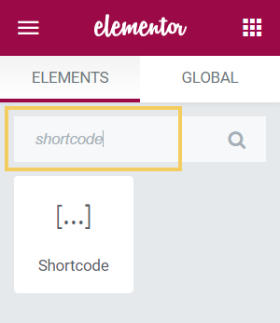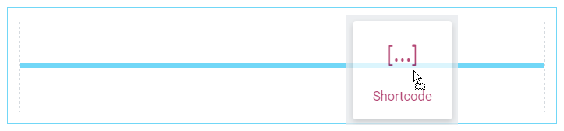

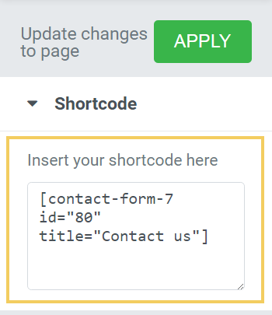 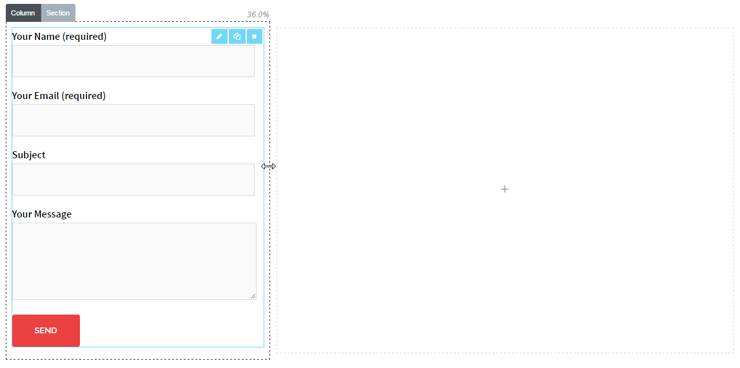

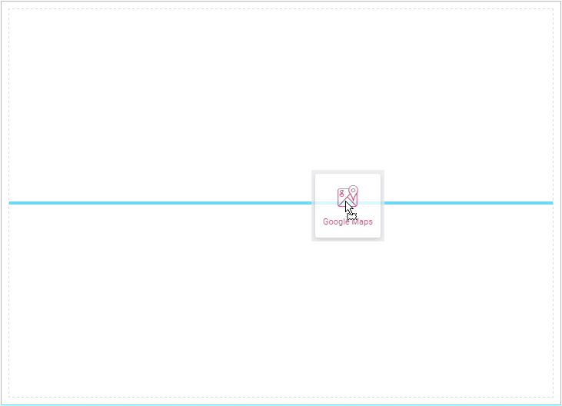

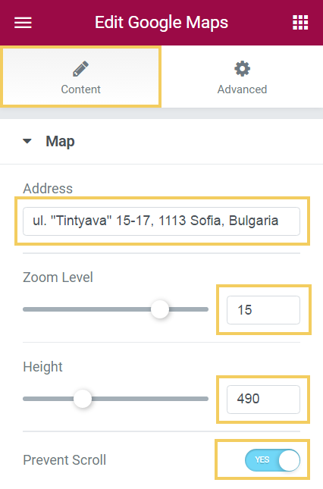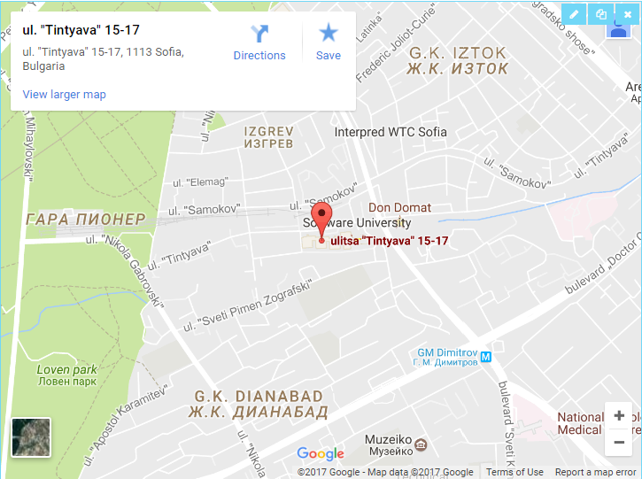

**Contact Form 7 is not responsive**, so you need to write **additional CSS styles** to make it behave correctly on tablets and smartphones:

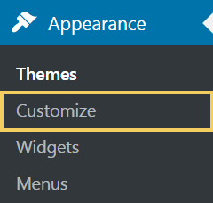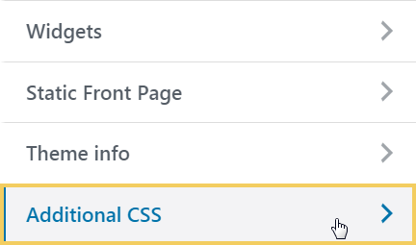

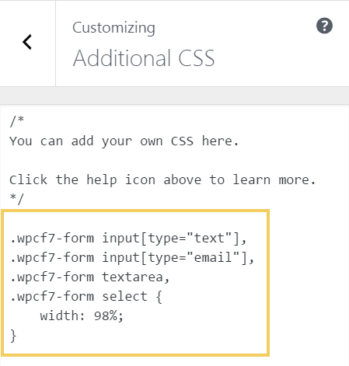

The **CSS code** is given below:

|  |
| --- |
| .wpcf7-form input[type="text"],  .wpcf7-form input[type="email"],  .wpcf7-form textarea,  .wpcf7-form select {  width: 98%;  } |

## Site Completed

Now you are done. Enjoy your first business WordPress site!

# What to Submit?

Create a **text file** or **Word document** or **PDF** (e.g. trifon-wordpress-homework.txt) holding your assets.

* Put in the file **screenshots** of all your pages.
* Insert the screenshots in tour homework document or upload them somewhere and provide links, e.g. <http://imgur.com/a/A2fA4>.

Submit your text file (or document) as **homework** at the course Web site.